Project overview
This Finance Collections – Non-Active Debtors (B2C) dashboard provides a monthly portfolio view of consumer customers who are no longer active but still hold outstanding debt, with a specific focus on accounts more than six months overdue.​
It equips the Finance Director with clear visibility of write-off risk, total exposure, and recovery performance, supporting decisions on provisioning, collection strategy, and expected write-offs.​
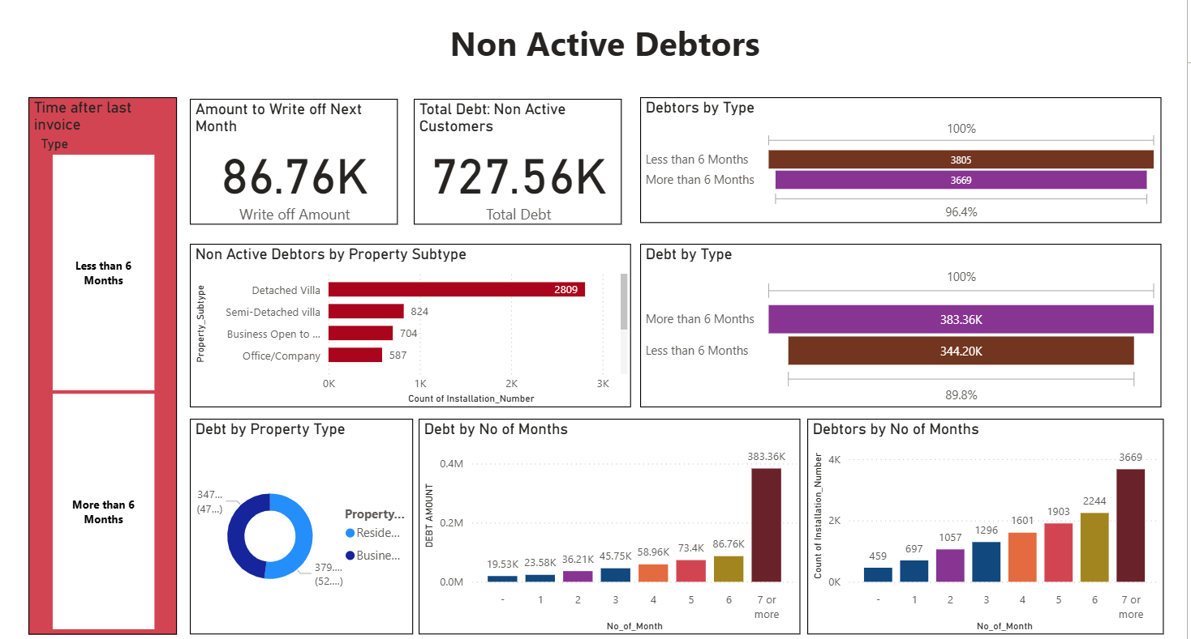
Business rules and scope
The report is scoped to B2C (consumer) debtors only, reflecting the different behaviour, risk profile, and regulatory expectations compared with B2B portfolios.​
Customers with age greater than 6 months since last invoice are treated as high-risk and feed into the “Amount to Write Off Next Month” metric, aligning with common bad-debt and tax-relief practices that treat 6-month-plus receivables as potential write-offs.​
Key KPIs and debtor segmentation
Headline KPIs show the Amount to Write Off Next Month and the Total Debt of Non-Active B2C Customers, giving immediate insight into expected losses versus total overdue exposure.​
The dashboard segments non-active debtors by time after last invoice (“Less than 6 Months” vs “More than 6 Months”), debtor type, property type, and property subtype, enabling the Finance Director to quickly identify which consumer segments drive the largest risk and where to target collection actions.​

Aging, debt distribution, and risk profile
Visuals such as Non-Active Debtors by Property Subtype, Debt by Property Type, and Debt by Type highlight how overdue balances are distributed across detached, semi-detached, business-open-to-public, and office/company properties within the B2C book.​
Charts for Debt by Number of Months and Debtors by Number of Months show how both the amount outstanding and customer count climb as accounts roll through aging buckets, making it easy to see the inflection point where debts older than six months become prime write-off candidates.​
Recovery rates by number of unpaid invoices
A dedicated matrix tracks Recovery Rates % by Number of Unpaid Invoices across the monthly portfolio, a key KPI for assessing B2C collections performance.​
For each row of customers with 1, 2, 3, 4, 5, or 6+ unpaid invoices, the report shows: portfolio size, number collected before rolling into the next bucket, and the calculated recovery rate = amount (or customers) collected ÷ total amount due, giving the Finance Director a clear view of how recovery performance deteriorates as invoice count and age increase.​
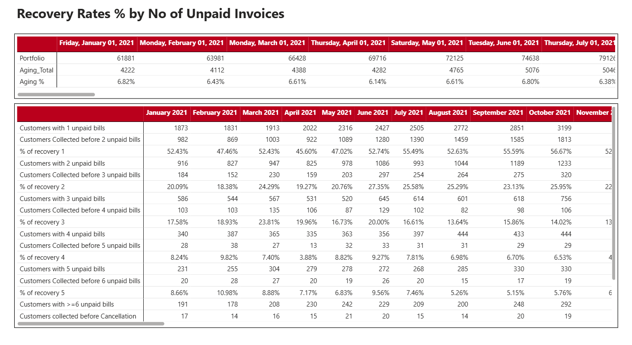
Power BI implementation and analytical value
From a Power BI perspective, this report combines KPI cards, bar charts, donut charts, and a scrollable matrix to follow finance-reporting best practice—executive KPIs at the top, analytical detail at the bottom, all driven by reusable DAX measures for aging, write-off amount, and recovery rate.​
These calculations are fully filter-aware (restricted to B2C, and to >6-month accounts for write-off logic), meaning the Finance Director can confidently slice the portfolio by month and segment while maintaining consistent treatment of high-risk, long-aged consumer debt.

